THE CULTURAL NETWORKS OF EUROPE.
TOWARDS EUROPE OF CITIZENS AND CIVILIZATIONS.

Nikolaos Karanikolas, karanik@topo.auth.gr
Peristera Lafazani, lafazani@topo.auth.gr
Myron Myridis, myridis@topo.auth.gr
Dimitris Ramnalis, ramnalis@topo.auth.gr

Aristotle University of Thessaloniki
Department of Cadastre, Photogrammetry and Cartography
P.O. Box 439, 54124 Thessaloniki
Τel. +30231 996133, fax +30231 996415

Abstract
Networks of several kinds are produced or organized in order to satisfy the requirements of new ways of presentation which serves the clientele.
Transportation, Energy, Communication of settlements, Metropoles, Technopoles networks offer recently a challenge to the traditional network mapping.
The European Continent, rich and prosperous in cultural heritage and events, seems to be a relevant geographical unit for such an effort.
The mapping of the cultural networks in Europe helps to make the complexity and the multiplicity of the European cultural history and the European contemporary cultural activities obvious.
In a set of thematic maps and cartograms we will try to show poles and axes, define centres and peripheries in order to assimilate the European integrity and diversification in culture and civilization.
Monuments, museums, theatres, cinemas as well as cultural cities, Eurocities and other topics will compose the cultural puzzle of points, lines and surfaces of the final dynamic thematic cultural map of Europe.

Key words: thematic cartography, geographical analysis
Introduction, the concept of networks.

The purpose of this project is the cartographical documentation of the cultural european networks. This documentation often embraces the modern logic of Cartography and data representation, through the internet.
The concept of networks has been represented cartographically and geographically by many scientists. Networks are referring to a group of people where each one contributes and shares responsibility for the final aim. At least, this is the case with today’s western society human networks.
Moreover, a network is a dynamic system that aims at the communication, the cooperation and corportation. (Definition by Anne van Otterloo και του Michel Bassand, in referrence to 'Working Groups: Network Solutions for Cultural Co-operation in Europe', ed. Judith Staines. EFAH/FEAP 1996.). A network is not a procedure that can be characterized as:

- Bureaucratic,
- Hierarchical,
- “Lobby”,
- Private,
- Temporary,
- Corporational,Federal,Associative ,
- «Club»

Networks constitute an organic development that emerges from the need of people for communication, exchange and common work. The actions, the information and the dynamics of a network are diffused horizontally from the sources of the networks to all of its nodal points.

European cultural networks.

European cultural networks and their contribution and advantages were recognized after the adoption of the resolution by the Congress of the Ministers of European Culture in 1991.
The purpose and contribution of the European culture networks are the following:

- To contribute to the European cohesion.
- To promote the transportation and mobility of both working people and cultural products.
- To promote communication between different civilizations in order to avoid phenomena such as xenophobia and racism, since communication helps people understand different cultures.
- The “strengthening” of urban societies by providing a democratic voice to different people.
- To develop various cultural dimensions those are not directly connected to economic factors.
- To promote cooperation between developed countries and the countries of the “Third World”

European cultural networks ensure some specific advantages in the European society, culture, politics and economy.
Specifically, European networks provide the following:

- An important system that facilitates and incites employment, since networks define and provide working places to young trainees, to employed people and people who ply a profession.
- A national governmental tool for the cover of specific cultural needs.
- A continuously increasing training in professions, that aims at the development of the qualifications of young people with the help of experts, in the area of culture.
- An efficient way of transmitting both the information and tendencies those are relevant to the development of forms and currencies in art, to the professionals of all fields of culture, also including the national governments.
- An efficient catalyst that aims at the international cultural cooperations’s invigoration.

The following table is an effort of recording and classification of the European cultural networks:

Network | Aim | Comments
Europa Nostra | Rescuing the cultural heritage of Europe. | More than 200 Organizations from european countries participate.
Organization of World Heritage Cities | Settlement network where Unesco list monuments are located. | 215 cities of total population 125 millions are participating.
Cultural capitals of Europe | The aim of the network is to “bring the European citizens closer to each other”. | Founded by initiative of Melina Merkouri, in 1985.
Eurocities | The complete development of the participating cities and the improvement of the quality of life of the European citizens as well. | 25 countries of total population 450 millions are participating.
Icomos | The rescuing and protection of cultural goods internationally.
Network of European Museums Organization | The exchange of opinions, knowledge and methods for both the political and technical solutions to problems that European museums face. | Museum connection and their representation in national and international Institutions.
European Network of Cultural Centers / Historic Monuments | The connection of places of cultural interest those are not located in cities. | 40 cultural “islands” , included in Europe or not, are already members of the network.
European Festivals Association | The promotion of cultural festivals through common politics, opinion exchange and member communication. | More the 100 Festivals from 38 countries participate.
International Federation of Film Producers Association | The ensurance of rights and Film Producers Association Policy. | 31 members of 25 of the most productive european countries are participating in the film making .
European Coordination of Film Festivals | The development of the European Cinema. | 250 European Festival are participating.
European Theatre Convention | The exchange of artistic opinions that concern the art of theatre. | 36 Theatre Institutions from 25 countries are participating.
European University Association | The network of universities and unions of heads of the universities of Europe. | 777 members from 45 countries are participating.
Table 1: The main European cultural networks.
The table that contains these 12 main cultural networks is a description of the cultural activity of the European citizens. It is more of a natural development due to the European Completion than a supplemental activity of the European Union. It is highly expected that the “common values” shared by the European countries might lead to a “common civilization”, in terms of “opinion exchanging” in cultures. On the other hand Europe has always been the geographical area of “cultural conflicts” in subjects that concern religion, language, East and West, North and South social and cultural differences, education, economic systems and geocultural choices.
Therefore, the “netting”, the integration in cultural orientations and the exchange of knowledge, techniques and opinions when applying these kind of networks is necessary.

[...] Netted Cities and Settlements.

In 2002 in the book «Global networks, linked cities» Saskia Sassen mentions that in the post-industrial era, some cities are already nodal points in network services- both economical and informative- of the world map. It is the phase of “urban development” that is called “global city web” and the role of the cities through the networks in which they are part of, reflects their development. Through the flow of information in these global networks, the development of European cultural networks of cities and settlements could be the European answer to the economic networks of other cities or perhaps the European Completion to these international networks, with emphasis to Europe’s cultural advantage.

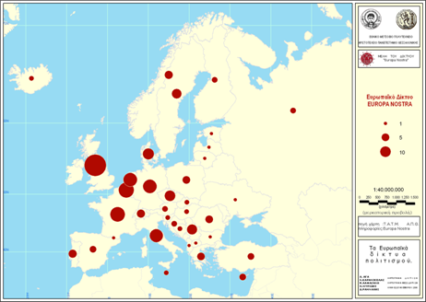

The Europa Nostra Network is a European network that includes over 200 National Organizations. The aim of the Network is to preserve the cultural heritage of Europe, and therefore, the network supports national and international efforts for the preservation of the cultural heritage, of architecture,of urban and land planning, mainly aiming at the development of the urban and agricultural areas.

Map 1: The Network Europa - Nostra.

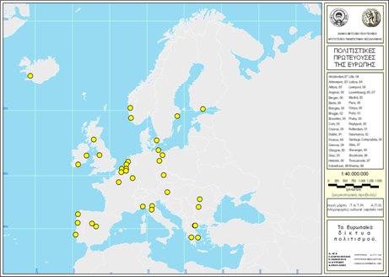

The Network of the cultural capitals of Europe is planned to «bring the European citizens closer» . It was founded in June 1985 under the initiative of Melina Merkouri.

Map 2: The cultural capitals of Europe.

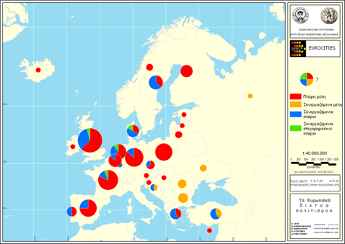
The «Eurocities» Network is a complicated organization of European cities. It includes 25 countries and a population number close to 450 million. The aim of the network is the complete development of the participating cities and the improvement of the quality of life of the European citizens.

Map 3: Eurocities Network.

The settlements’ networks are essentially the reflection of the the European dogma «think global, act local» a dogma that the local political authorities mainly support. Thus, the cities’ and settlements’ networks are often a result of the local communities’ effort that mainly aims- besides the permanent need for communication and exchange of opinions- at the cities’ promotion, tourism, the local products’ promotion and the local development in general.
The main target of these networks is the establishment of a common local policy in the field of urban culture.

Museums, culture and festivals.

A second category of networks, concerns networks that reflect culture through the European Museums, the local Festivals and exhibitions that also constitute the nodal points of these networks. Tiziana Terranova in her book «Network Culture. Politics for the information age» when referring to the main characteristic of the 21st century, implies the need for information, information that merely emerges through connection and communication. Besides, this is one of the main targets of these networks.

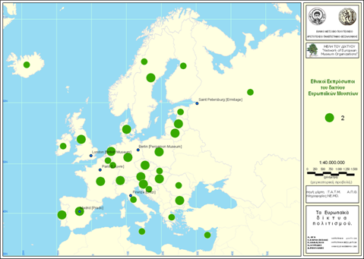

The NEMO Network connects all the museums in the European Union, as well as museums that collaborate with the E.U. Its main target is the representation of the museums in organisations and
Institutions,the exchange of opinions, knowledge of methods and techniques for the solutions (political and technical) to problems that the museums may face today.

Map 4: The “European Museum Organizations” Network.

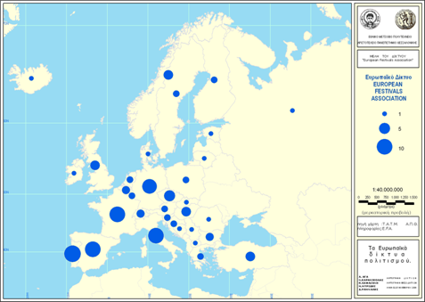

This network includes more than 100 festivals
of the european area, in 38 countries in total. Its aim is the promotion of the festival- members of the network through the finding of a
common policy, the opinion exchange, and the members’ communication. There are two Festivals participating from Greece(the Epidauros Festival and the Dimitria in Thessaloniki).

Map 6: The “European Festivals Association” Network.

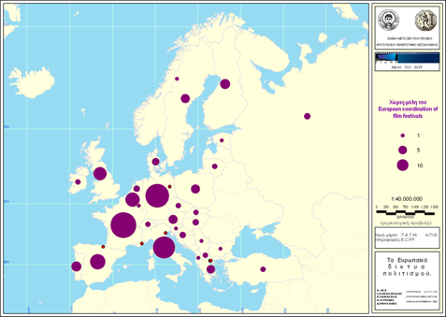

This Network includes
31 members of the
25 most productive in film making countries. One of the main targets of the network is the
ensurance of the members’ interests, and their products’ rights, the companies’ policy, the technological support, e.t.c.

Map 7: European Coordination of Film Festivals.
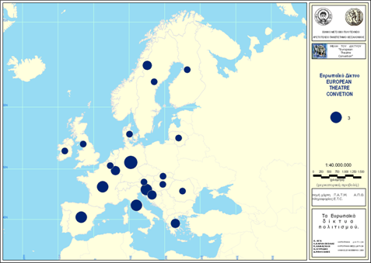
This network includes
36 theatre institutions in 25 European countries. It was founded in 1988 and its main target is the exchange of opinions that concern art and theatre. Greece participates with two members: The experimental Stage of Art (Amalia theatre) and the National Theatre.

Map 8: European Theatre Convention.

Education “in contact”.

James Cornford και Neil Pollock in their book «Putting the University Online. Information, Technology and Organizational Change», use as first phrase the following: “universities are in crisis” implying the deep changes that occure in the universities when it comes to the use of internet in both educational programs from distance as well as the communication between the Institutions.
These questions lead to the creation of networks that connect the educational Institutions. These networks’ main target is the communication of the various educational Institutions for the achievement of an education of a higher quality.
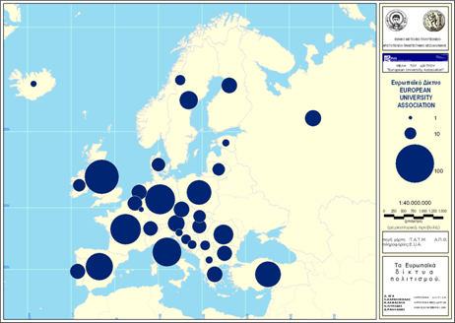
This network embraces universities and national assosiations of heads of universities. It is the bigger university network in Europe with 777 members from 45 countries in total. Greece participates in this network with 18 Institutions in total.

Map 9: European University Association.

Synthetic approach of the cultural networks.

The representation of networks is a complete cartographic process, that is also the ignition for a geographic approach of the correlation of networks that belong to a common group, concerning their aim and approach in geographical space.

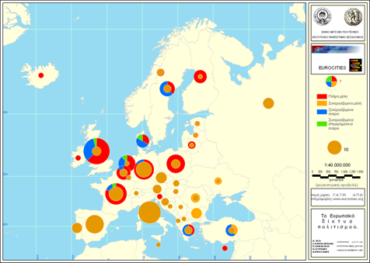

Map 10: Synthetic approach of the cultural settlemens through European networks.

The synthetic representation of the Eurocities, and World Heritage Cities Networks, indicates the spatial correlation of these two networks.
It concerns a sequence of cities that coexist in these two networks, where the most intense cities are the cities of Central and Northern Europe.
Films are not the only connection in the European art, but it is the kind of art that has attracted the majority of European citizens over the past years.
Europeans tend to watch movies in cinemas more than going to theatres or various exhibithions etc. Moreover, cinema is a form of continuous contact with art, since it is presented in a different way compared to other arts, such as concerts for example. It is an everyday activity that implicates art, that almost each European attends. Thus, the representation of the Film Producing Companies, in relation to the Film Festival Network, is a very interesting subject.
In this map the networks of the European Coordination of Film Festivals and International Federation of Film Producers Association are represented.

Conclusions

The representation of Europe’s culture, at least the way this culture is expressed through the development of various networks is a very complicated cartographic procedure, at least when it comes to the expression of the development of various network forms and spatial networks.
The representation of the phenomena, to a national level, is the natural sequence to the collection of data of the networks through the information they provide to the internet and media.
The spatial positioning of these networks appoints the development of “cultural Europe” which is a result of the areas dynamics, as it develops through the state- members’ correlations and policies and is also highly related to the existance of national cultural units that constitute and emanate from the differencies in cultures and life style that characterize the european countries over the past centuries.
This project does not end in the thematic representation of the cultural European Networks, but aims to constitute an observation tool of these networks with the use of maps. Maps, in refference to this paper, constitute the necessary “magnifier” in representing the various spatial and cultural correlations. The cultural “cores” of Western Europe develop properly towards the countries of Eastern Europe and the horizontal development of these networks could possibly constitute the next level of this development. The “cultural spreading out” of the european networks towards the Eastern countries is a phenomenon that is recorded, represented and observed through thematic cartography and its tools.
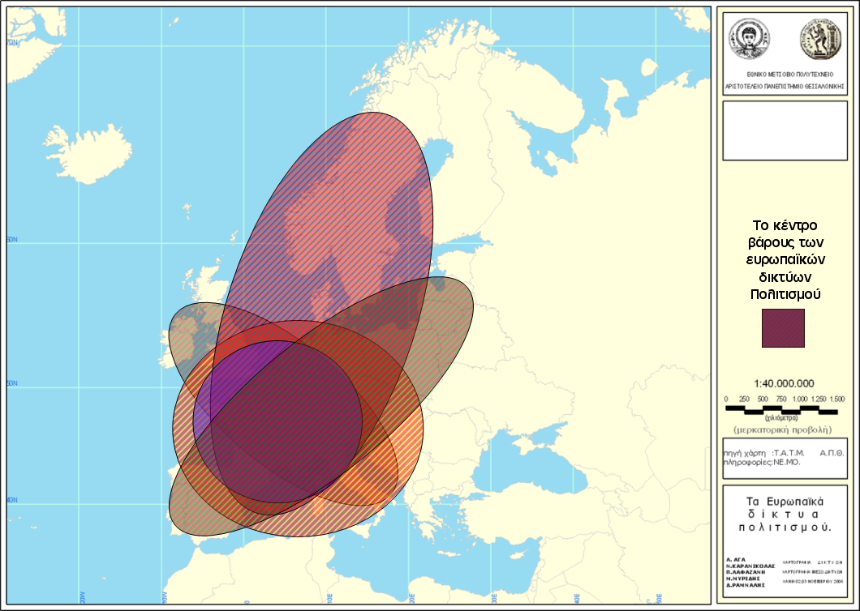

Map 11: Representation of the “cultural core” of the European networks.
References

- Van Otterloo Anne, Bassand Michel, Working Groups: Network Solutions for Cultural Co-operation in Europe, 1996, ed Judith Staines. EFAH/FEAP.
- Sassen Saskia, 2002, Global networks, linked cities, Routledge, New York.
- Terranova Tiziana, 2004, Network Culture. Politics for the information age, Pluto Press, London.
- Castells Manuel , 1996, The Rise of the Network Society, Blackwell Pub.
- http://europa.eu/
- http://whc.unesco.org/en/map/
- http://www.accr-europe.org
- http://www.accr-europe.org/default.aspx
- http://www.auth.gr/inter/memberships/index_el.html
- http://www.culturelink.org/
- http://www.danceeurope.net/
- http://www.efa-aef.org
- http://www.etc-centre.org
- http://www.eurocities.org/main.php
- http://www.eurofilmfest.org
- http://www.eurofilmfest.org
- http://www.europanostra.org/
- http://www.european-heritage.net/
- http://www.fiapf.org/default.asp
- http://www.insidefilm.com/festsbylocation.html
- http://www.iofilm.co.uk/
- http://www.ne-mo.org/index.html
- http://www.ovpm.org/
- http://www.sostapalmizi.it/netmanifesto.htm

